Transformer

Definition: -
The transformer is a static electro-magnetic device that transforms one alternating voltage (current) into another voltage (current). However, power remains the some during the transformation. Transformers play a major role in the transmission and distribution of ac power.
Principle: -
Transformer works on the principle of mutual induction. A transformer consists of laminated magnetic core forming the magnetic frame. Primary and secondary coils are wound upon the two cores of the magnetic frame, linked by the common magnetic flux. When an alternating voltage is applied across the primary coil, a current flows in the primary coil producing magnetic flux in the transformer core. This flux induces voltage in secondary coil.
Transformers are classified as: -
- Based on position of the windings with respect to core i.e.
- Core type transformer
- Shell type transformer
- Transformation ratio:
- Step up transformer
- Step down transformer
- Core & shell types: Transformer is simplest electrical machine, which consists of windings on the laminated magnetic core. There are two possibilities of putting up the windings on the core.
- Winding encircle the core in the case of core type transformer
- Cores encircle the windings on shell type transformer.
- Step up and Step down: In these Voltage transformation takes place according to whether the
Primary is high voltage coil or a low voltage coil.
- Lower to higher-> Step up
- Higher to lower-> Step down

Bridge rectifiers:
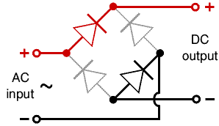

There are several ways of connecting diodes to make a rectifier to convert AC to DC. The bridge rectifier is one of them and it is available in special packages containing the four diodes required. Bridge rectifiers are rated by their maximum current and maximum reverse voltage. They have four leads or terminals: the two DC outputs are labelled + and -, the two AC inputs are labelled .
- The diagram shows the operation of a bridge rectifier as it converts AC to DC. Notice how alternate pairs of diodes conduct.
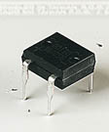 | 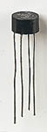 | 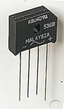 | 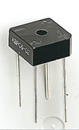 | 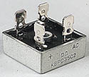
Various types of Bridge Rectifiers
Note that some have a hole through their centre for attaching to a heat sink

A transformer is a device that transfers electrical energy from one circuit to another through inductively coupled conductors—the transformer's coils. A varying current in the first or primary winding creates a varying magnetic flux in the transformer's core and thus a varying magnetic field through the secondary winding. This varying magnetic field induces a varying electromotive force (EMF) or "voltage" in the secondary winding. This effect is called mutual induction.
If a load is connected to the secondary, an electric current will flow in the secondary winding and electrical energy will be transferred from the primary circuit through the transformer to the load. In an ideal transformer, the induced voltage in the secondary winding (V_{s}) is in proportion to the primary voltage (V_{p}), and is given by the ratio of the number of turns in the secondary (N_{s}) to the number of turns in the primary (N_{p}) as follows:
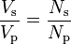
By appropriate selection of the ratio of turns, a transformer thus allows an alternating current (AC) voltage to be "stepped up" by making N_{s} greater than N_{p}, or "stepped down" by making N_{s} less than N_{p}.
In the vast majority of transformers, the windings are coils wound around a ferromagnetic core, air-core transformers being a notable exception.
Transformers range in size from a thumbnail-sized coupling transformer hidden inside a stage microphone to huge units weighing hundreds of tons used to interconnect portions of power grids. All operate with the same basic principles, although the range of designs is wide. While new technologies have eliminated the need for transformers in some electronic circuits, transformers are still found in nearly all electronic devices designed for household ("mains") voltage. Transformers are essential for high voltage power transmission, which makes long distance transmission economically practical.

Basic principles:
The transformer is based on two principles: first, that an electric current can produce a magnetic field (electromagnetism), and, second that a changing magnetic field within a coil of wire induces a voltage across the ends of the coil (electromagnetic induction). Changing the current in the primary coil changes the magnetic flux that is developed. The changing magnetic flux induces a voltage in the secondary coil.
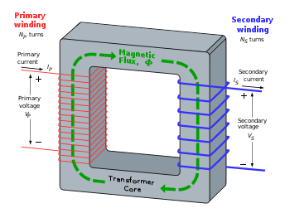

An ideal transformer
An ideal transformer is shown in the adjacent figure. Current passing through the primary coil creates a magnetic field. The primary and secondary coils are wrapped around a core of very high magnetic permeability, such as iron, so that most of the magnetic flux passes through both the primary and secondary coils.

Induction law
The voltage induced across the secondary coil may be calculated from Faraday's law of induction, which states that:
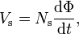

Where V_{s} is the instantaneous voltage, N_{s} is the number of turns in the secondary coil and Φ is the magnetic flux through one turn of the coil. If the turns of the coil are oriented perpendicular to the magnetic field lines, the flux is the product of the magnetic flux density B and the area A through which it cuts. The area is constant, being equal to the cross-sectional area of the transformer core, whereas the magnetic field varies with time according to the excitation of the primary. Since the same magnetic flux passes through both the primary and secondary coils in an ideal transformer,^{[29]} the instantaneous voltage across the primary winding equals
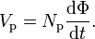

Taking the ratio of the two equations for V_{s} and V_{p} gives the basic equation^{[30]} for stepping up or stepping down the voltage
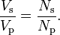

Classification
Transformers can be classified in many different ways; an incomplete list is:
- By power capacity: from a fraction of a volt-ampere (VA) to over a thousand MVA;
- By frequency range: power-, audio-, or radio frequency;
- By voltage class: from a few volts to hundreds of kilovolts;
- By cooling type: air-cooled, oil-filled, fan-cooled, or water-cooled;
- By application: such as power supply, impedance matching, output voltage and current stabilizer, or circuit isolation;
- By purpose: distribution, rectifier, arc furnace, amplifier output, etc.;
- By winding turns ratio: step-up, step-down, isolating with equal or near-equal ratio, variable, multiple windings

Types of transformers
There are six different types of transformers we will address in this hub and none of them will be related to a toy or a movie. Transformers are a type of passive electronic component that are used to step up or step down the voltage in a circuit or system.
The voltage transformer is similar to the more common power transformer. It is also referred to as a potential transformer. It is used for metering and protection in high voltage circuits. It is designed in order to achieve an accurate voltage ratio over the range of the load and is often used to step up low voltages or step down high ones.
The power transformer is the most commonly used transformer. One thing to remember is that a transformer doesn't actually create power, but transfers it from one coil winding to another. The power transformer is actually a type of voltage transformer and it is used in many different power type applications. Some of these transformers are immersed in oil in order to keep them cooler and stop them from overheating.
The current transformer is also known as a series transformer. It is often placed in series with a high current circuit. It is used for the measurement of electric circuits and they are often used in metering and protective relays.
As the name implies, the impedance transformer was designed to ensure accurate impedance transformation. For example, a transformer may be used to "match" the impedance of an amplifier to a speaker. In fact, they are often used in low-frequency amplifiers.
The Isolation transformer has no direct connection between windings, but they are connected via the magnetic flux in the core. In most cases, the winding ratio is a one to one. In other words, it is neither a step up, nor a step down but a means of isolating the circuit from the power supply.
Lastly, the auto transformer in unique in its tapped windings. The primary is normal, but the secondary has at least three taps where electrical connections can be made and these different taps result in different voltages. They are often used in applications where it is needed to interconnect systems operating at different voltages.
This list is by no means complete. There are other transformers that have not been addressed in this Hub, such as the audio transformer. It is, however, representative of many, if not most of the transformers used in electronic circuits.

